**Project Planning Phase**

**Project Planning Template (Product Backlog, Sprint Planning, Stories, Story points)**

|  |  |
| --- | --- |
| Date | 09 November 2022 |
| Team ID | PNT2022TMID11845 |
| Project Name | Project – Smart Fashion Recommender Application |
| Maximum Marks | 8 Marks |

**Product Backlog, Sprint Schedule, and Estimation (4 Marks)**

Use the below template to create product backlog and sprint schedule

|  |  |  |  |  |  |  |
| --- | --- | --- | --- | --- | --- | --- |
| **Sprint** | **Functional**  **Requirement (Epic)** | **User Story**  **Number** | **User Story / Task** | **Story Points** | **Priority** | **Team**  **Members** |
| Sprint-1 | User Interface (Front End) | USN-1 | The user gets visualizations of the landing page and register pages through which they can sign up or login. | 20 | High | Abhishek A R  Charan D P  Devendran V  Hari Krishnan  N |
| Sprint-2 | Administrator Handle | USN-2 | The administrator can login to the database and upload the products and shipper details | 20 | High | Abhishek A R  Charan D P  Devendran V  Hari Krishnan  N |
| Sprint-3 |  | USN-3 | As a user, I can register for the application through Facebook | 20 | Low | Abhishek A R  Charan D P  Devendran V  Hari Krishnan  N |
| Sprint-4 |  | USN-4 | As a user, I can register for the application through Gmail | 20 | Medium | Abhishek A R  Charan D P  Devendran V  Hari Krishnan  N |

**Project Tracker, Velocity & Burndown Chart: (4 Marks)**

|  |  |  |  |  |  |  |
| --- | --- | --- | --- | --- | --- | --- |
| **Sprint** | **Total Story Points** | **Duration** | **Sprint Start Date** | **Sprint End Date (Planned)** | **Story Points**  **Completed (as on**  **Planned End Date)** | **Sprint Release Date (Actual)** |
| Sprint-1 | 20 | 6 Days | 24 Oct 2022 | 29 Oct 2022 |  | 29 Oct 2022 |
| Sprint-2 | 20 | 6 Days | 31 Oct 2022 | 05 Nov 2022 |  | 07 Nov 2022 |
| Sprint-3 | 20 | 6 Days | 07 Nov 2022 | 12 Nov 2022 |  | 12 Nov 2022 |
| Sprint-4 | 20 | 6 Days | 14 Nov 2022 | 19 Nov 2022 |  | 19 Nov 2022 |
|  |  |  |  |  |  |  |
|  |  |  |  |  |  |  |
|  |  |  |  |  |  |  |
|  |  |  |  |  |  |  |

**Velocity:**

Imagine we have a 10-day sprint duration, and the velocity of the team is 20 (points per sprint). Let’s calculate the team’s average velocity (AV) per iteration unit (story points per day)

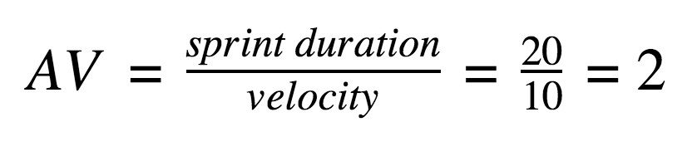

**Burndown Chart:**

A burn down chart is a graphical representation of work left to do versus time. It is often used in agile [software development](https://www.visual-paradigm.com/scrum/what-is-agile-software-development/) methodologies such as [Scrum.](https://www.visual-paradigm.com/scrum/scrum-in-3-minutes/) However, burn down charts can be applied to any project containing measurable progress over time.

